AI Based Virtual Assistant

**Prof. Deepali Deshpande**  
Artificial intelligence and DatScience Vishwakarma Institute of TechnologyPune, India  
deepali.deshpande@vit.edu

**Aniruddha Joshi**  
Artificial intelligence and Data Science Vishwakarma Institute of TechnologyPune, India  
aniruddha.joshi20@vit.edu

***Abstract: As the world is moving towards automation using AI to make life easier. Virtual assistants are also becoming the need of the day, especially for those , who have tedious work and the one having the language problem. It is also interesting for one who is keen to work with AI and likes automation. The research paper demonstrates the virtual assistants for the WINDOWS using Artificial Intelligence technique and also with modules and packages in python.***

***Keywords****:* Artificial Intelligence*, Automation, Python , VS Code, Windows*

1. ***INTRODUCTION***

In the 1990s, speech recognition technology came into existence for the personal Computers of IBM, Philips and Lernout & Hauspie. In 1994, The technique was used for the Smart phones. But till then, the system was able to identify the speech, not anything else useful. Python was not explored enough. Later on , around 2015, These smartphones provide features from face ID to augmented reality with the help of AI. Today, AI is booming the market and thus the interest of the whole world by creating the natural human – machine – Interaction . Most of the smartphones are using the virtual assistant technology like Cortona, Siri, Alexa, Google assistant, etc. using Artificial Intelligence. But to our surprise, there is no such complete assistant for windows platform. The aim is to develop and design an interactive and complete virtual assistant for windows and simplify the tasks for the user. It takes the input from the user through audio (can be text) and gives the appropriate output in various forms by performing the commands.**

**fig1. Basic Idea**

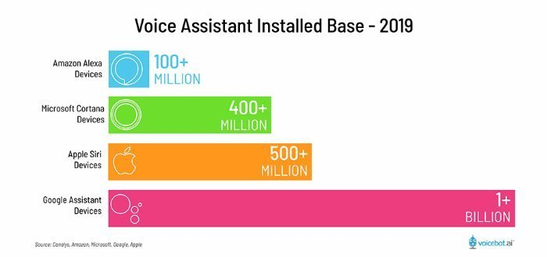

**fig2. Voice Assistant Installed Base-2019**

1. ***LITERATURE SURVEY***

Dr.M. Sharada Varalakshmi, Dr.P. Lavanya,Sai Prakash Reddy in their paper, ‘Jarvis - A Virtual Assistant based on Artificial Intelligence’ suggest that, Basics of the project are grounded in the frequency and its analysis. This paper has examined voice acknowledgment calculations which are significant in improving the voice acknowledgment execution .(which is significantly different from Alex assistant.)The procedure had the option to verify the specific speaker dependent on the individual data that was remembered for the voice signal.

According to the paper ‘AI Based Voice Assistant Using Python’ published by Deepak Shende, Ria Umahiya, Monika Raghorte, Aishwarya Bhisikar, Anup Bhange, they built an assistant using AI and IOT. As a backend they have used the python libraries and tools. It not only works on human commands but also gives responses to the user on the basis of a query being asked or the words spoken by the user such as opening tasks and operations.

Author Yogendra Kumar Sharma, Neeraj Sharma. published a paper ‘A Review Paper on Smart Personal Assistant’.According to the paper, an Assistant provides natural language interaction to the user’s device, with the coordination of a range of specialist job assistants. The architecture used is a BDI architecture for coordination and dialogue actions, and communication between agents. The programming languages used to develop the program are Java, Prolog, and C++ and it runs on the SUSE Linux Enterprise server 11 operating system using Apache's OOP architecture that allows distributed computing.

The project ‘Smart Python Coding through Voice Recognition’ developed by M. A. Jawale, A. B. Pawar, D. N. Kyatanavar addressed the problem of students while the users are continuously typing for the computer program. According to them, the machine will take the input through voice and will compare it with the stored keyboard and thus develop the program. With the languages mentioned , they are going to do tedious tasks simpler.

In the paper ‘Opportunities for Automating Email Processing: A Need-Finding Study  
’, authorsSoya Park, Amy X. Zhang, Luke S. Murray, David R. Karger researched on the problem of sending the repetitive as well as all the categories regarding email addressing. They gathered information about email processing and users in a datasheet. The paper says that they have developed the YouPS API interface where email addressing becomes a non tedious task.

1. ***METHODOLOGY***
2. To explore the tasks that are to be performed.
3. Study the modules and packages required to fulfill the task
4. Using appropriate OOP language and interpreter.
5. Defining the functions for appropriate commands and training the system with proper logic to understand commands.
6. Initialising loops and handling the dataset.
7. Exploring maximum possible commands.

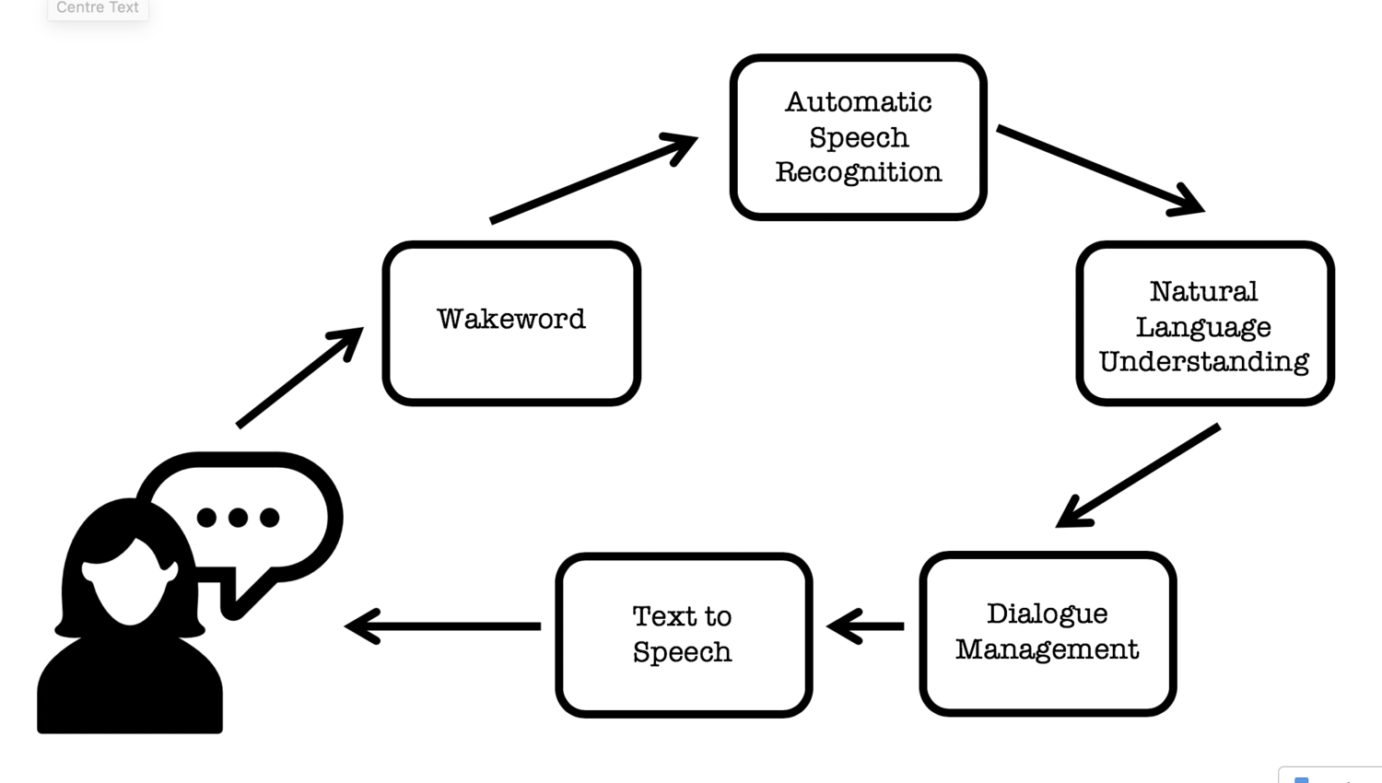

**fig3. Backend discussion**

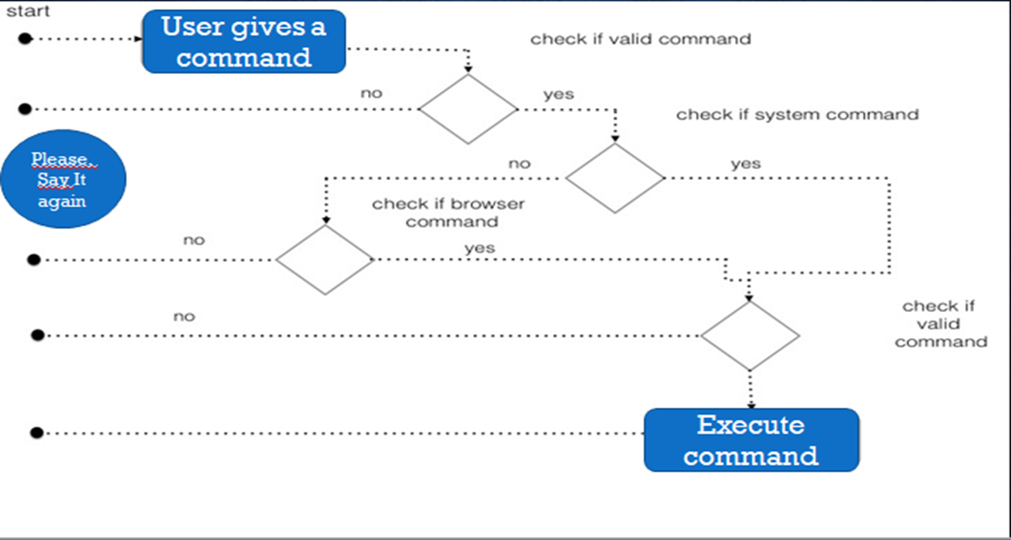

**fig3. Action Plan**

* ***Tools & Technology***

1. Visual Studio Code
2. AI
3. Computer Vision
4. Python OOP
5. Objects and Functions
6. Modules like pyautogui, wikipedia, pyttsx3, speech_recognition, open cv, etc..
7. ***RESULTS AND DISCUSSIONS***

The developed system has voice enability and console interface in a Visual Studio Code. The name given to the assistant is ‘Alex 2.o’. After running the program, the assistant gives his introduction, wishes the user and asks for the task or a command.

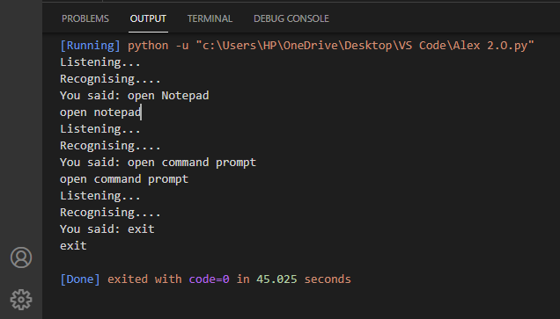

**fig4. Command Interface**

When the user gives command, Alex 2.o fetches the keywords and completes the task. As the assistant is for a complete windows system, it has been loaded with numerous tasks such as opening the notepad, command prompt, playing a song, telling jokes, shutting down the system.. and the list continues. It can also do some online tasks with the help of the Internet such as searching on web, you tube, sending an email with the help of voice virtual commands. It also prints the commands on the console as an output. It is a small system of AI and will add effect in automation in future.

1. ***LIMITATIONS***
2. As there is no GUI made. So it should be operated on console
3. The system should have Internet connectivity. (Which is now a days world wide available)

1. ***FUTURE SCOPE***

As the basic and main aim of this project is already satisfied which was to create an AI based virtual assistant. But still the model can be modified by exploring the commands. Automation especially in today’s world is a never ending thing. Model can also be updated by adding google maps as well as location access to the user. Predictions and some data analysis can also be loaded in the system so that users will be able to predict future results.

1. ***CONCLUSION***

We have been impressed and influenced by the automation in the field of AI. So it needs a voice recognition system and there was not any for the windows system. So the system developed is basically AI Based Virtual Assistant using python. Basically, the system takes the input from the user through voice commands and responds appropriately to the user. The task is never going to be completed. It can be updated from time to time. The platform that we have used is the VS Code. It has its own security and hence security issues are not there so far. So now the model performs various tasks based on the commands. Whether the tasks are online or offline, doesn’t matter. The system is efficient to do so.

1. ***APPENDIX***

1. ***ACKNOWLEDGEMENT***

In our project of ‘AI Based Virtual assistant’, we would especially like to thank my project guide Deepali Deshpande madam who directed me during the whole project preparation and moderated me during the presentation of the project. Also I am especially grateful to all the authors and research paper publishers who published important information on AI & Speech automation technology which was very helpful for us throughout the project to enrich our knowledge and apply in the project.

1. ***REFERENCES***
2. Dr.M. Sharada Varalakshmi, Dr.P. Lavanya, Sai Prakash Reddy, “Jarvis - A Virtual Assistant based on Artificial Intelligence”, 2020,http://sersc.org/journals/index.php/IJGDC/article/view/33420

1. Deepak Shende, Ria Umahiya, Monika Raghorte, Aishwarya Bhisikar, Anup Bhang, “AI Based Voice Assistant Using Python”, 2019,https://www.jetir.org/view?paper=JETIR1902381

1. M. A. Jawale, A. B. Pawar, D. N. Kyatanavar, “Smart Python Coding through Voice Recognition”,2019, https://www.ijitee.org/wp-content/uploads/papers/v8i10/J12070881019.pdf
2. Yogendra Kumar Sharma, Neeraj Sharma, “A Review Paper on Smart Personal Assistant”,2016,https://www.ijert.org/a-review-paper-on-smart-personal-assistant
3. Soya Park, Amy X. Zhang, Luke S. Murray, David R. Karger, “Opportunities for Automating Email Processing: A Need-Finding Study”, 2019,https://people.csail.mit.edu/soya/papers/mailbot.pdf